**Excel Assignment – 7**

Q1) Using Insert Function, give examples of any function available in the different dropdowns present in the function library. For example AutoSum, Recently Used, Text, Date & Time, etc..

ANS: Using insert functions the other functions available in dropdown are

* Days360
* DATE
* AVERAGE
* SUM
* IF
* HYPERLINK
* MAX
* SIN
* SUMIF

Q2)What are the different ways you can select columns and rows?

ANS: * You can select the rows and columns by pressing left click and dragging the mouse cursor from one cel to the cell that we want to select

* You can also click on the small triangle icon to the left side of Column A and above Row 1 that will select the all rows and columns in the worksheet

* you can also press CTRL + SHFIT AND the Arrow key to select all the cells in a table in certain direction

Q3. What is AutoFit and why do we use it?

Ans: AutoFit is a feature in Excel that allows you to quickly adjust the row height or column width to fit the text completely  , so that there is no spilling over to other cells.

4. How can you insert new rows and columns into the existing table?

Ans: Right click on any Row or Column inside the table and select Insert . The new row will be inserted below the selected Row and same done on the Column will insert the new column to the right side of It .

Q5. How do you hide and unhide columns in excel ?

Ans: * Select the Entire column by clicking any albphabet 🡪 Right click and then you will get the option to hide the column . you can also unhide by the same method .

* The other method is by setting up the width of the column to 0 , That will automatically hide the column

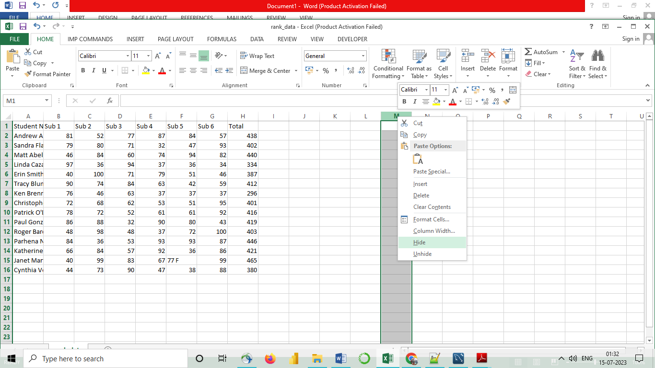

Q6) Create an appropriate table within the worksheet and use different functions available in the AutoSum command.

Ans:autosum: sum

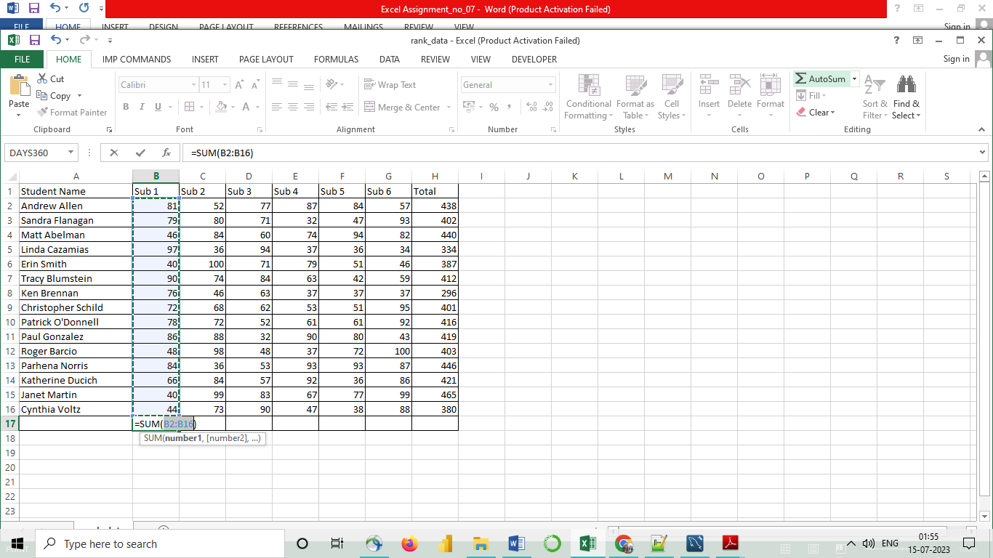

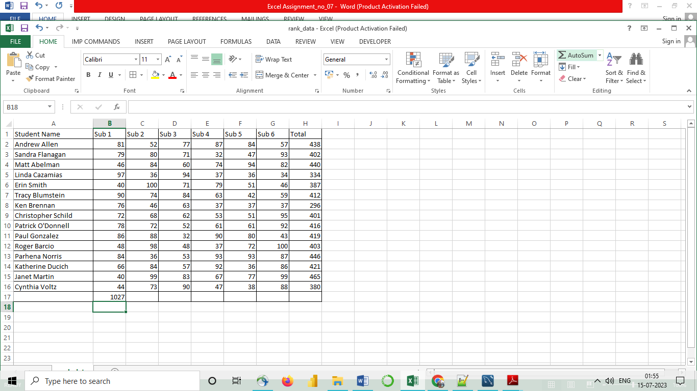

Autosum : average

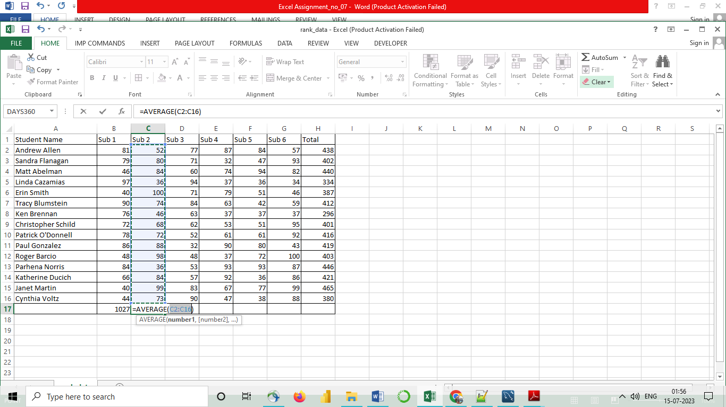

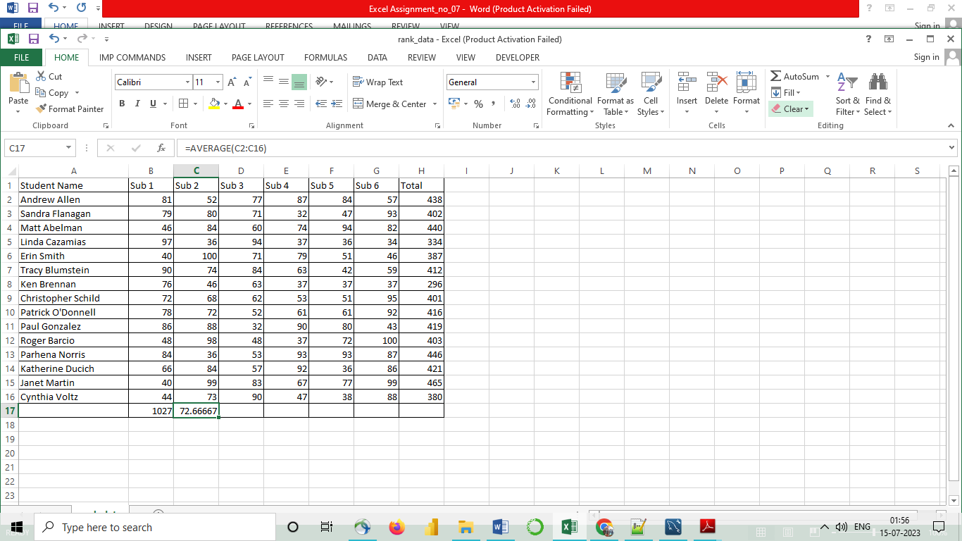

Autosum: Count

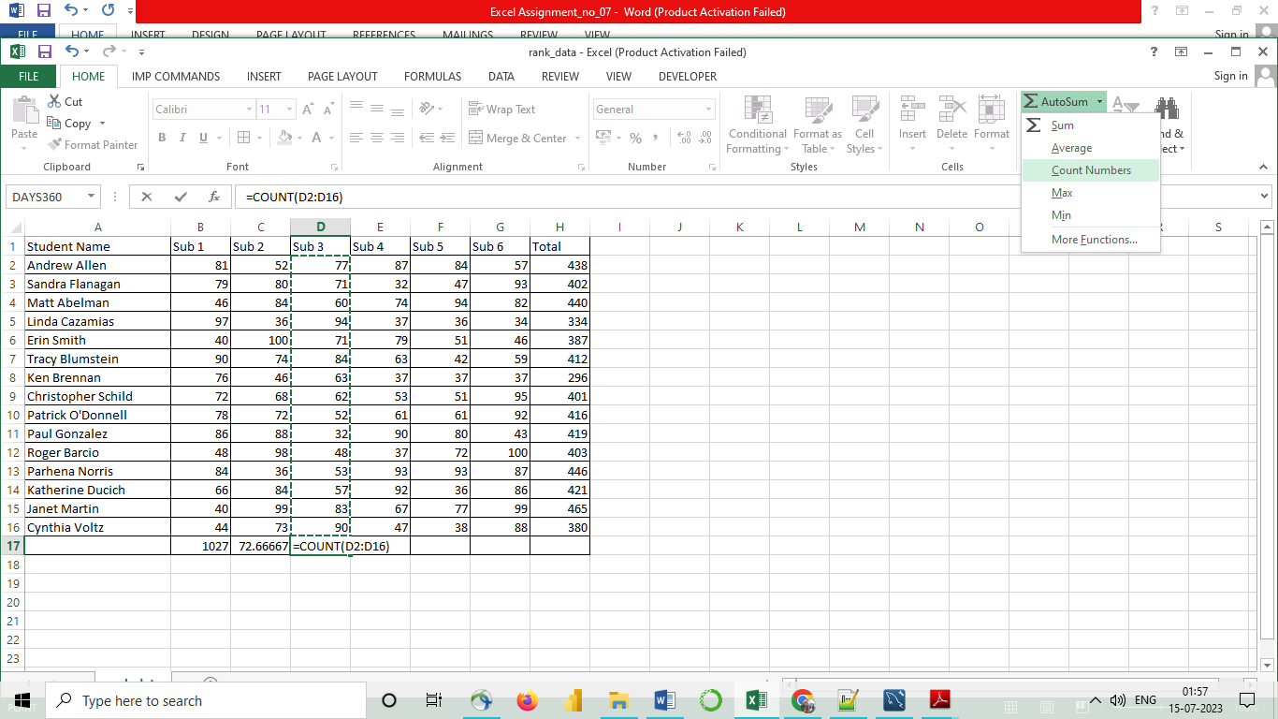

Max

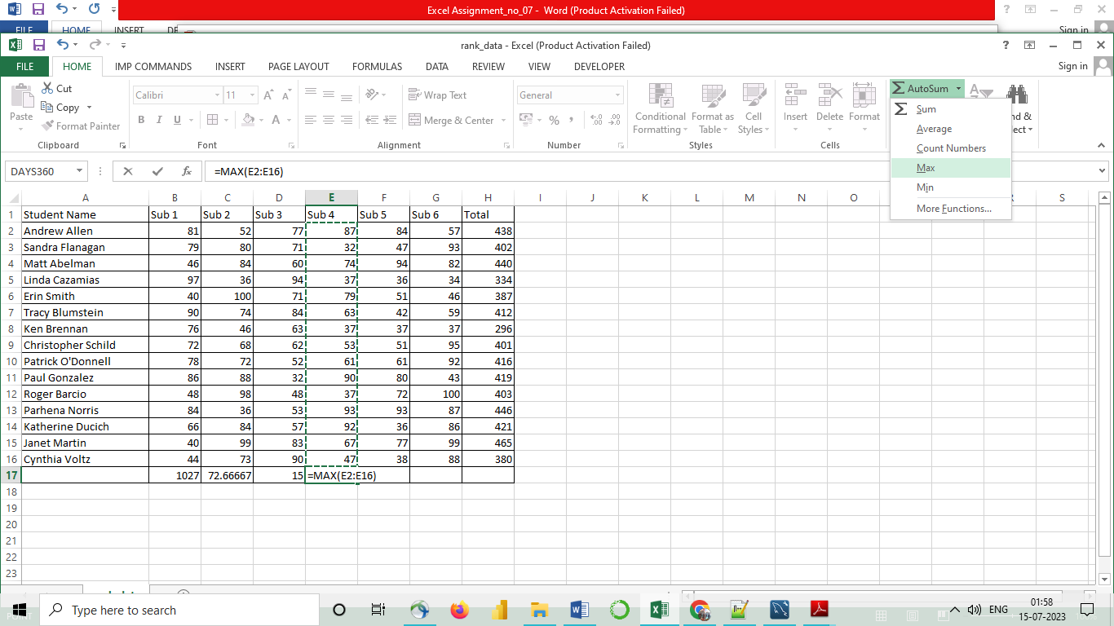

MIN

